Dear Arkansas School Administrator:
Our annual Art Educator’s Fall Conference is scheduled for November 12th and 12th, 2015. We are pleased to announce that Dr. George Szekely, National Art Education Association President Elect, will be our Keynote speaker. Dr. Szekely has published 11 books and over one hundred and fifty articles in major journals of education. “George Szekely has been a pioneer in developing creative changes and methodologies for art teaching.” Your help in allowing your art teachers to attend this conference will provide needed encouragement, knowledge and enthusiasm for art teachers throughout Arkansas.
Art teachers attending our annual conference report the primary reason they choose to attend is because we provide the best opportunity for them to receive professional development directly related to work they do with students. Educators will receive an average of 15 developmental hours designed to provide skills for the implementation of Common Core in the arts, integrate new technology in the arts and present innovative ways to reach special needs children in the arts.
Please allow and encourage your art teachers to attend our 2015 Arkansas Art Educator’s Conference. It is the diversity of ideas from art teachers throughout the state that make this conference outstanding.

Sincerely,
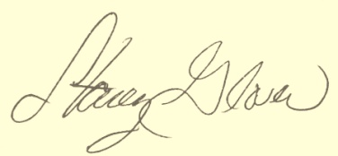

Stacey A. Glover
President, Arkansas Art Educators

