To Whom It May Concern:

This year the Arkansas Art Educators are offering our fall conference $10.00 to first year art teachers. In order to provide this service, we are requesting that our teachers provide evidence of being a first year art teacher. This letter is to be hand delivered at conference upon receiving pre-registration materials.

This letter is to certify that ______________________________ is a first year art teacher in ______________________________ school district. He or she has not taught art in any other district or state prior to the 2018-19 school year.
Thank You for your help in this matter.

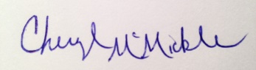
Cheryl N McMickle
President, Arkansas Art Educators

Signed _________________________________ Date ________________
(Superintendent)
__________________________________
(School District)

Signed _________________________________ Date ________________ (Principal)
__________________________________
(School)

Signed _________________________________ Date ________________
(Art Teacher)

