Dear Arkansas School Administrator:

Our annual Arkansas Art Educators Fall Conference is scheduled for November 1st and 2nd, 2018. We are pleased to announce that Cheri Lloyd will be the keynote speaker on Thursday. Cheri will provide and engaging presentation of how an art educator and intervention specialist developed a class to address student social-emotional needs through the arts.
The Keynote speaker on Friday will be Michael Warren. During the session participants will learn unique, innovative ways to foster original and meaningful ideation in art students k-12.
Your help in allowing your art teachers to attend this conference will provide needed encouragement, knowledge and enthusiasm for art teachers throughout Arkansas. Art teachers attending our annual conference report the primary reason they choose to attend is because we provide the best opportunity for them to receive professional development directly related to work they do with students.
Educators will receive an average of 15 developmental hours in the following areas:
    - Art skills and techniques
    - Integration of Art with STEM (STEAM)
    - Formative and Summative Assessments
    - Parent and Community Involvement
    - Special Needs Students
    - Behavior Management
    - Technology in the Art Classroom
Please allow and encourage your art teachers to attend our 2018 Arkansas Art Educators Fall Conference. It is the diversity of ideas from art teachers throughout the state that make this conference outstanding.

Sincerely,
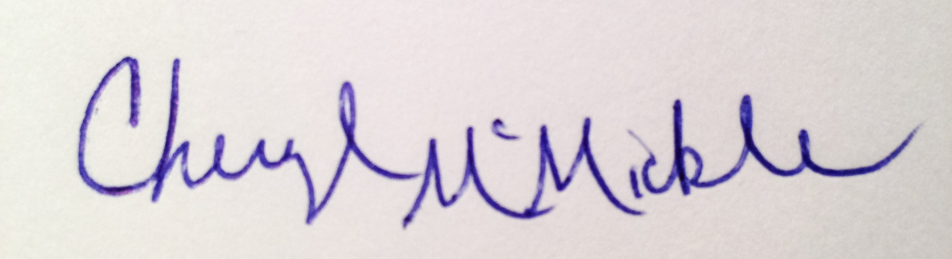
Cheryl N McMickle
President, Arkansas Art Educators

