Dear Arkansas School Administrator:

Our annual Arkansas Art Educators Fall Conference is scheduled for November 6-8, 2019. Our opening reception will be held at the new Windgate Center for Art &Design on the UALR campus Wednesday evening. We are excited to hear about all the programs for teachers they will be offering and to see this new facility.
We are pleased to announce that Bob Reeker, NAEA Western Region Vice-President will be the keynote speaker on Thursday. He will speak on the benefits of communication, collaboration, and community as a professional, advocator and leader.
The Keynote speaker on Friday will be Steve Fielding, “ Mud & Fire: How to Implement a Ceramics program to Enhance Your School’s Art Curriculum”.
Your help in allowing your art teachers to attend this conference will provide needed encouragement, knowledge and enthusiasm for art teachers throughout Arkansas. Art teachers attending our annual conference report the primary reason they choose to attend is because we provide the best opportunity for them to receive professional development directly related to work they do with students.
Educators will receive an average of 15 developmental hours in the following areas:
    - Art skills and techniques
    - Integration of Art with STEM (STEAM)
    - Formative and Summative Assessments
    - Parent and Community Involvement
    - Special Needs Students
    - Behavior Management
    - Technology in the Art Classroom
Please allow and encourage your art teachers to attend our 2019 Arkansas Art Educators Fall Conference. It is the diversity of ideas from art teachers throughout the state that make this conference outstanding.

Sincerely,
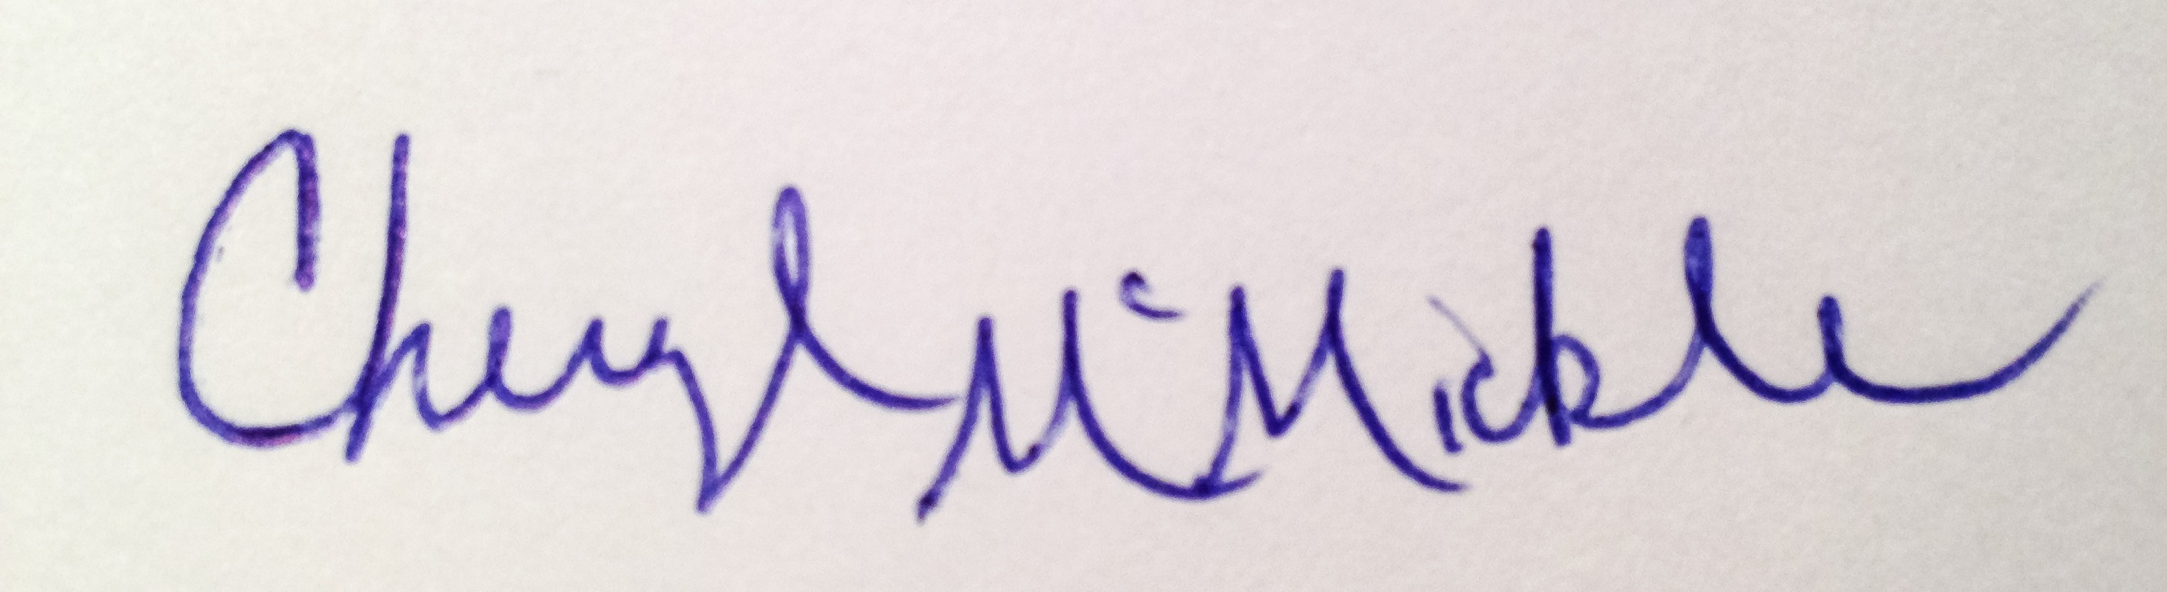
Cheryl N McMickle
President, Arkansas Art Educators

