Ephemeral Art
*Nature Mandalas….go on a walk and create nature mandalas from gathered objects (leaves, pinecones, flowers, etc.)
*Balloon Lift….Tie messages or drawings to helium filled balloons and set them into flight.
*Sidewalk Chalk Memorial…Practice the art of letting go by creating a work of art with an expiration date.
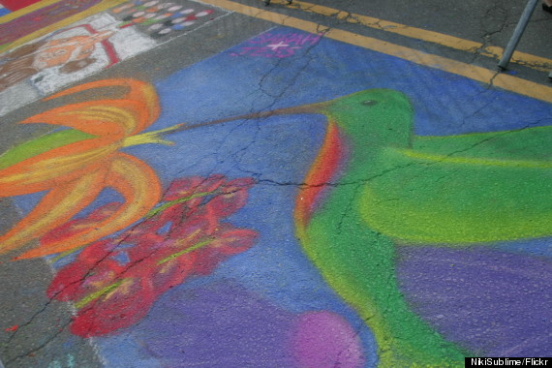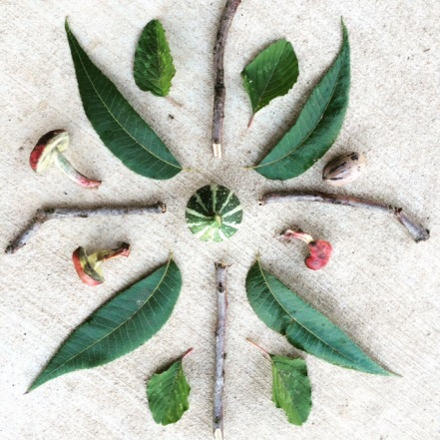

Prayer Flags …Have each child draw a picture; write a poem, etc... with fabric markers on a small piece of stretched white fabric. Let them choose a fabric swatch, and use fabric glue to piece onto background fabric and add embellishments. This can also be done with paper. There are tons of resources for studying prayer flags in Tibetan culture.

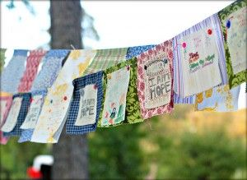

Messages in a Bottle (Jar)…Each student writes a message/goodbye to a loved one or friend who has passed and places it in a jar. The jars can be decorated with mosaic stones, modge podged with pictures or quotes. Jars could also be decorated and used as lanterns holding small votive candles as memorials.

Postcards From Your Future Self Use cardstock cut into postcard sizes. On the front, create an image that represents something about how you would like your life to be in the future (for example, five years from now).
On the back, write a note from your future self – give yourself advice or encouragement, describe what life is like for you in the future, and explain how you got there. You can easily cut card stock into postcard sized rectangles and use your medium of choice, collage, drawing, painting, etc. This activity helps students think beyond the fact that the pain of today will eventually lessen and that the future is filled with hope.

Graffiti Wall This activity is really simple but effective. Use a large sheet of bulletin board paper and markers. Tape the large sheet to a wall that is accessible to students. It encourages students to express their emotions in a fun and casual way. It gives students an outlet that is easily accessible. It gives students control over when and how they express their emotions and also eliminates the pressure and time constraints of more structured activities. It allows students to be subtle about expressing their emotions. They don’t have to start a conversation or go out of their way to say ‘Look, this drawing represents how I feel’.
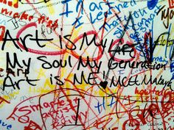

Mandalas
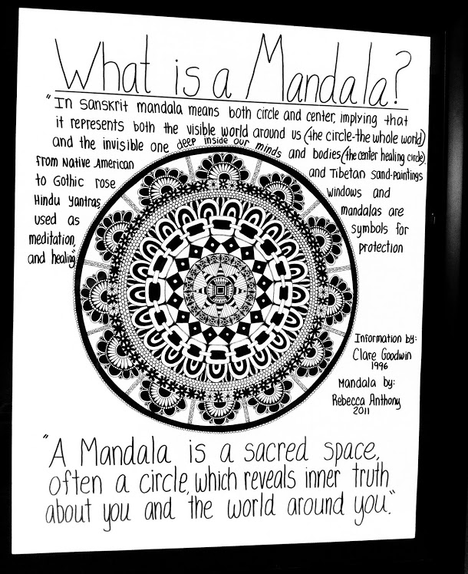
There are literally hundreds of Mandala lesson plans for every grade and using every media. I’m including a few of my favorite lessons here:
http://www.incredibleart.org/lessons/middle/Larry-radial.htm
http://rubinmuseum.org/images/content/Pre-Visit_Lesson_Plan_and_Handouts_-_Marvelous_Mandalas.pdf
http://www.essexgarner.com/Radial%20Balance%20Mandala%20Lesson%20Plan.htm (elem. level)
http://www.thesmartteacher.com/exchange/resource/588/Personal_Symbol_Mandala (middle level)

Art Journaling Art Journaling is a great way to allow students to create without pressure. We can use handmade journals for a specific purpose such as reflecting or responding to an event. This site has some great instructions:
http://inquisitiveartteacher.blogspot.com.es/2014/07/art-journal.html
There are also journals made from discarded books, and journals that are ongoing projects. Some teachers use specific prompts for students to use as inspiration and others (like me) use them as a free time project.
Here are some great sites for Journal ideas and prompts:
http://daisyyellowart.com/vividlife/art-journaling-for-kids-teens.html
http://imaginationsoup.net/2012/09/06/4-ways-to-express-who-you-are-art-journal-activities-for-kids-and-adults/
http://artjournalist.com/2013/04/how-to-prepare-an-old-book/ (how to use old books)
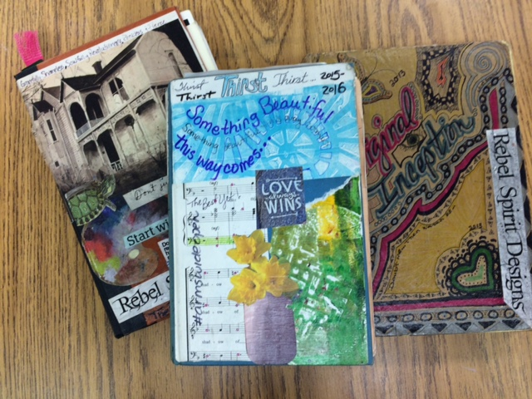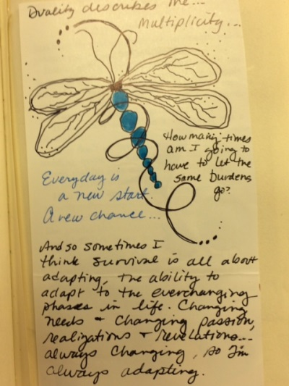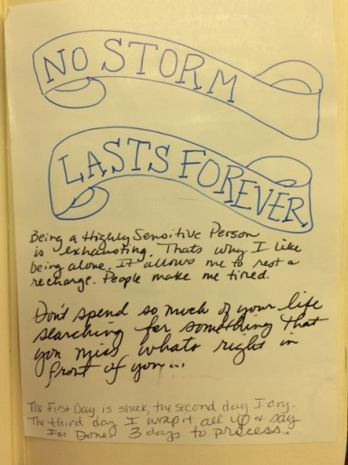

Healing Heart
“We used large red roll paper to cut out a gigantic heart. We then cut the heart into squiggly lined pieces. We made enough pieces so that each member of the group and both of us would have a piece. We then labeled the back of the heart so we would remember how it went back together. Note: I highly recommend doing that! It made it so much easier to put it back together.
We explained to students that everyone in the group has experienced a loss or multiple losses of people they care about. We passed out a piece of the heart to each student. We instructed them that they could use the piece of the heart to draw a picture, write a memory, share a message, or decorate however they wanted to honor the losses they have experienced. Students utilized crayons, markers, and colored pencils to write on their heart pieces.
After everyone was done working on their heart piece, we asked if anyone wanted to share what they created. Everyone was open and willing to share their creation with the group. We had the students help us put the heart back together. We used tape to affix the heart on to a window. We passed out bandages to students and had them put bandages on the parts of the heart where the pieces met each other.
We explained that although our hearts have been broken by the losses we have experienced, together as a group we can heal. The heart is hanging in a prominent place visible to the students and serves as a constant reminder of how we are healing together. (schcounselor.com)
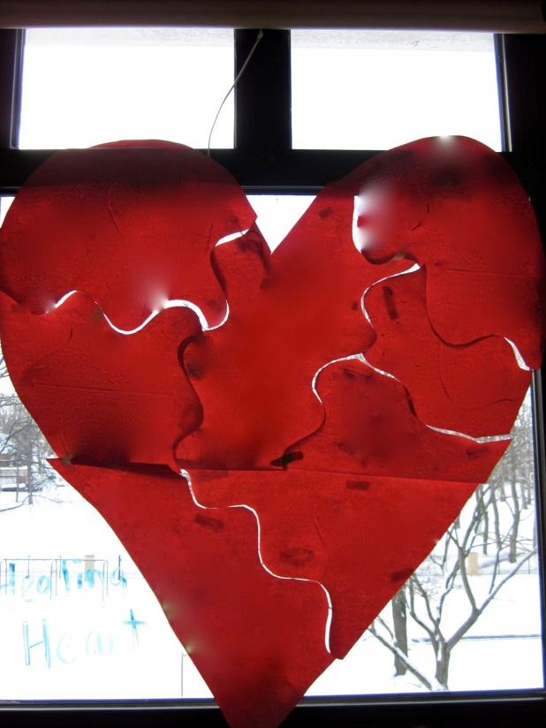

Memory Ornaments I love this project because it can include all students. Each student can make an ornament or commemorate a loved one or a special person they’ve lost. I’ve even had students make one for a beloved pet. This project includes all students and doesn’t just focus on the ones that were closest to the person that has been involved in a tragedy. Students may also use the ornament as a gift.
There are ornaments available at craft stores that are clear balls which can be taken apart and objects placed in the ball. I’m more inclined to use this project in a way that is very cheap or even free. There are dozens of ways to make an ornament that are cheaper than buying the clear balls. We’ve used copies of photos for a photo transfer process using modge podge and tag board. Another option is salt dough.
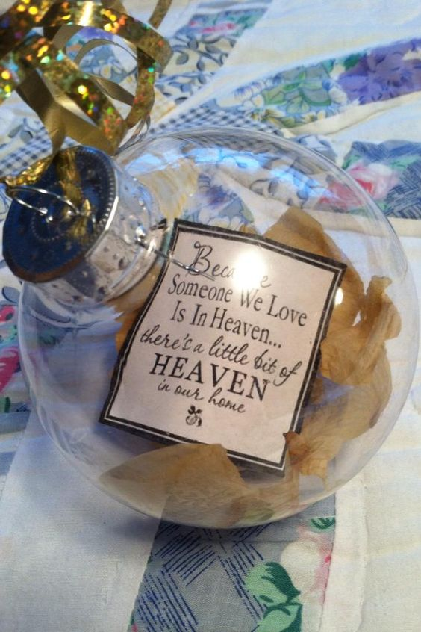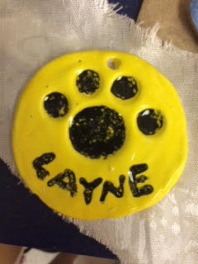

Inspiration Stones We collected flat stones on a walk around the school. Getting out and getting fresh air is a welcome relief when there is so much emotion going on inside the school. We then painted pictures or messages on them with Sharpie paint pens and with Sharpie markers. We tried to focus on a message that would make a friend feel better. Getting students to think of something other than their own pain is helpful. It takes the focus off them for a while. Some students wrote scriptures on their stones. We intended to leave them in places that someone might find them, but most students ended up giving theirs to a friend or taking theirs home. I know of a few who just kept them in their lockers.
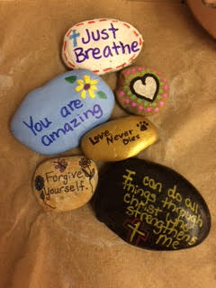

Healed Hearts This is a project that you could do using fabric glue or needle and thread, depending on the age you do it with. The premise is that our hearts become wounded and suffer losses throughout our lives, yet we still carry on as survivors. This project speaks to us words or endurance. It says, “We hurt a lot right now, but we will be ok.” Students generally respond very well to projects that they can feel, touch and hold. Students cut out 2 hearts out of fabric, decorate them with colored thread, wire, buttons, etc. (representing hurts and losses) and then they attach them together. They should leave a space unsewn to be able to stuff the heart with poly-fil.
Original tutorial with pics is located here:
http://alisaburke.blogspot.com/2010/02/healed-heart-tutorial-and-giveaway.html
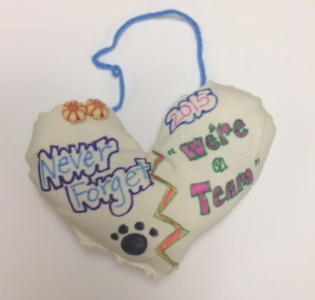

Puzzle Memorial This is another project that is widely adaptable. We used poster board to cut puzzle pieces (drawn and numbered on the back first) so each student that wanted to participate could take a piece and write a favorite memory, draw a picture, or whatever they felt like doing with the piece. We then constructed it back together to symbolize that we were all struggling to make sense of the loss, but that we were in the process of healing together and that each of us supported the other ones. This could be displayed in the classroom, hallway, or given to the family that has lost someone.
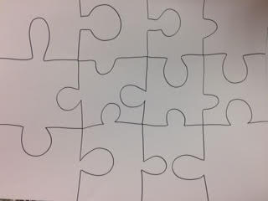

Memory Book This is the same concept as the puzzle activity above but more versatile in that it can involve more students. Each student adds a page to the book with their favorite memory or message or drawing to the book and it’s given to the family. Some students might not be comfortable with others reading what they wrote, so it might be a good idea to check before sharing the contents with other students.

Collaborative Collage This picture is of an unfinished collage. The one my students actually worked on was 3 sheets of poster board. Each class, as well as any students who had permission to come from other classes worked on it throughout the day for several days. We filled it with positive words to encourage and lift up each other as we worked through the toughest first days after losing a classmate. In the middle were the words “Lift Up DHS”, surrounded by positive and encouraging words from magazines.
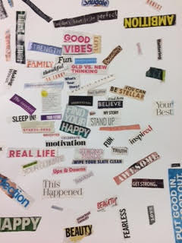

Collaborative Family Gift This project involved the Ag and Shop classes. It was actually a project put together by the football team and the kids in Ag. They wanted to make something for the family to show how much they would miss the student as part of their team. I got involved because I had the paint! (As usual) It turned out that the boys cut out helmet shapes in Shop class, brought them to Art where they were painted by anyone that wanted to help paint them. They were then nailed to a post to put in the yards of all the family members. Yes, it was a little crazy for a few days, but it would have been anyway. The students being able to come together for a common purpose was really good for them.
