Welcome to the 2018 Arkansas Art Educators Fall Conference

Hello Artfully Minded Educators,
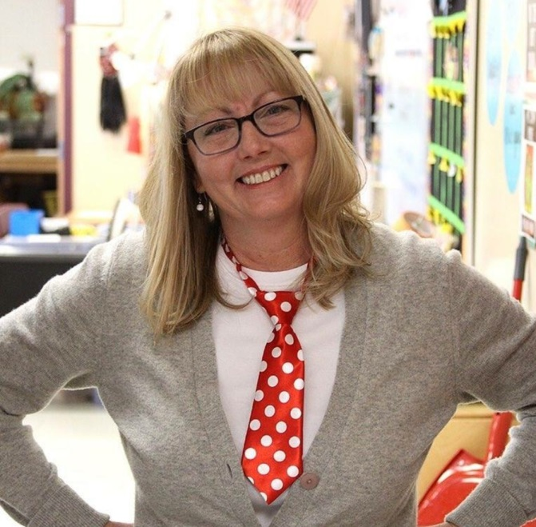
Welcome to the Arkansas Art Educators Conference! This is my favorite time of year! I have made wonderful connections with artfully minded educators across the state; connections that have helped me grow as an educator. This conference is a place where we can immerse ourselves in all things ART. “Art is when you hear a knocking from your soul — and you answer.” ~Terri Guillemets. The conference goal is to help you with INNOVATIVE and creative ideas to take back to your classroom and most importantly, to your students. My hope is that the conference inspires you to facilitate student growth and to feed the soul, both yours and your students.
Charity McCartney
President-Elect
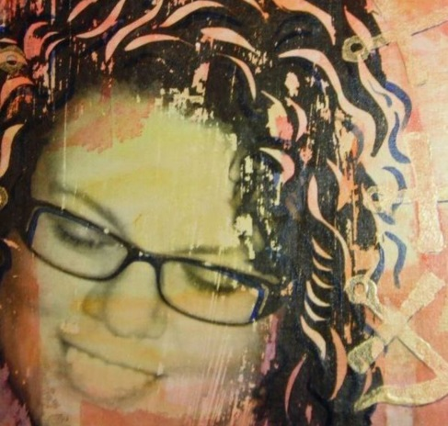
Welcome to the AAE Fall Conference!
Do a little search about innovation or being innovative and you will find words like: process, inventive, initiative, creative, flexible, risk-taking, effective, and engagement. These are all ideas that we want our students to understand or exhibit. They are also skills we as educators must possess to effectively teach those students.
Here’s to all of us enjoying a time of innovative discovery. Relax with old friends. Make some new ones. Learn some new skills. Carry them back to your work place. This network, this tribe as we love to call it, is only as strong as the links in its chain. Now more than ever our students, schools, and communities need us to be innovative.
Cheryl McMickle
President
Keynote Speakers

Cheri Lloyd
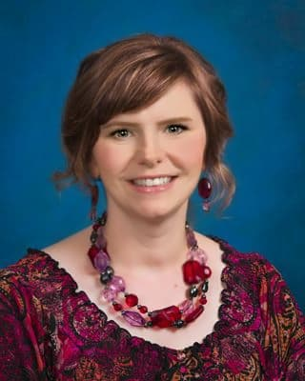
Cheri Lloyd has been an educator for the last 19 years. She taught for 16 years in public schools in Wisconsin, California, and Washington. She has developed new visual and digital art programs at two separate school districts and spent 3 years as Region 6 Lead and Visual and Performing Arts Program Coordinator for a county office of education where she specialized in arts integration and STEAM professional development for educators.
Cheri has spent the last two years on the Long Beach Peninsula of Washington studying and developing an art program that uses the arts as a way to deal with students with high levels of Adverse Childhood Experiences (ACEs).
Michael Warren
As the founder and lead developer of Terra Forma Cards, Michael Warren has 16 years of experience in visual arts education. Currently he is the Director of the Moody Advanced Professional Studies program for Highland Park ISD in Dallas, Texas. He received his BFA in Visual Arts Studies from the University of North Texas, followed by a MA in Visual Communications from Texas A&M Commerce. Michael has extensive experience teaching all levels and mediums of art, including each of the portfolios in Advanced Placement and International Baccalaureate, as well as STEAM integration. He has had a passion for professional development for most of his career. Michael is a cofounder of the Florence Master Class and has recently been developing and presenting sessions for teachers with content ranging from media-specific development in the visual arts, to design thinking and cross curricular planning.
WEDNESDAY, OCTOBER 31

7:30-8:30 - PRE-PREGISTERED participants may pick up their conference packets outside the Silver City Ballroom Area at the hotel

ON- SITE REGISTRATION WILL BEGIN AT 7:30 AM, THURSDAY MORNING

Session Number 001 6:00 - 8:00: Clinton Presidential Center (Library)
Please join us for the opening reception of the Arkansas Art Educators annual conference. Conference attendees are invited to a reception and presentation in Forty-Two, followed by an after-hours tour of the museum and the special temporary exhibit, 25 Years of American Craft. President Bill Clinton and Hillary Rodham Clinton celebrated the “year of the craft” in 1993 by assembling a collection of 75 contemporary American pieces, which were displayed at the White House, and will be on display at the library.

THURSDAY, NOVEMBER 1

There are limited, experience (hands-on) workshops available. Participation in these workshops is reserved when pre-registering. If additional seating is available tickets will be available at the registration table.

All sessions are one hour unless stated otherwise

SC- Silver City (sections 1, 2, 3, 4, 5, 6), BD-Blue Dog, D-Decantillion,

RW- Razorback West, RE-Razorback East, H- Hospitality Suite 1005
AT-Arkansas Traveler (upstairs)

HS- High School, MS- Middle School, E- Elementary, A- All Levels

Vendor Exhibits and Art Makerspace Silver City 6, 7
Thursday 10:00 AM -5:00 PM
Friday 10:00 AM- 12:00 PM
Teachers will experience hands-on learning by participating in various vendor stations that will include ideas for visual art, STEAM and maker education. Come explore ideas for animation, robotics, coding and more as it ties to the visual art, design thinking, and studio habits. After participating enter for a chance to win some of the hands-on tools used.

002 8:30 AM SC 1,2,3,4 Keynote Speaker Cheri Lloyd
AIM: Arts, Identity, and Mindfulness
Schools all over the nation are facing high numbers of students dealing with ACEs (Adverse Childhood Experiences). Recent research has found that students dealing with high a ACEs score directly affects their ability to learn. Learn how an art teacher and intervention specialist developed a class called AIM designed intentionally to address student identity and mindfulness, using the arts to channel angst and help students gain resiliency.
Unlimited A

Thursday November 1

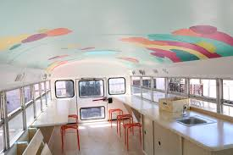
003 Intervals North Parking Lot Van Gogh; A Mobile Art Center
Art Feeds presents Van Gogh, a Mobile Art Center dedicated to all things creative! We have paired with Sakura International to create a make and take project with their gel pens and cray pas, as well as a collaborative community art piece. Join us on board to relax, explore, express and get creative. This is on a first come first served basis.
10:00 AM, 11:15 AM, 12:30 PM, 1:45 PM, 3:00 PM, 4:15 PM
Limited A

004 10:00 AM SC 1 Thea’s Art Closet and Scholarships Paul Leopoulos
Acquire information about how to apply for Thea’s Art Closet grants and education on Thea Scholarships for High School Seniors.
Unlimited A

005 10:00 AM SC 2 Choice Based Art for High School Joy Schultz
This session is to group up and discuss our journey to Choice Art. Learn important structures you need to support the students’ journey to design, plan, and scale up their original work. Learn how to set a work flow for pushing the students forward and techniques on how to maintain, track and collect data on each student. Experienced Choice Art educators are welcome to share strategies that work.
Unlimited HS

006 10:00 AM SC 3 ADE Update: Hot Topics in Art Education Lana Hallmark
Lana Hallmark, Fine Arts Specialist at the Arkansas Department of Education, presents an update on state policies impacting arts education, including opportunities for the arts through district ESSA plans, the revised Standards of Accreditation, the 2019 STEAM initiative, Arts Advocacy Day and the upcoming revision of the Arkansas Academic Standards for Fine Arts. A portion of the session will be a brainstorming and a listening session, giving arts educators in the field early input regarding the state fine arts standards.
Unlimited A

007 10:00 AM SC4 In the Garden Angela LaPorte
This presentation is an example of how a group of students from Jr. High, college and a program for disabled adults collaborated during an art unit on gardens as a part of university service learning course.
Unlimited A

008 10:00 AM SC5 Get This Party Started! Games in Art Jennifer West
Looking for a way to get more student engagement in your classroom? Struggling with student apathy and disinterest? In this session, we will look at one way to encourage student engagement by getting students excited to come to the art room. Yes, even that “too cool” football player who didn’t even want your class in the first place. Resources include lesson plans, templates, and game examples. Question and answer segment will allow teachers to collaborate on ways to alter resources to better suit their individual needs.
Unlimited HS

Thursday November 1

009T 10:00 BD Gee’s Bend: The Quilt, The Story Shelly Wheeler
Gee’s Bend is an African American Community in Boykin, Alabama. Although most well known for their beautiful quilts, we will also be discussing the civil rights injustice that spanned well over 40 years in this small community. Participants will be creating a paper quilt square using recycled materials. This lesson can easily be adapted as a cross-curricular project for K-12 students.
Ticketed A 100 minutes

010T 10:00 AM D Artistic Adventures in African American Art
Becky Thornton and Mary Ann Ray
Come celebrate our African American Artists and be inspired by the rich heritage of Romare Bearden, Faith Ringgold, Elizabeth Catlett, Jacob Lawrence, Rashawn Penister and John Bigger, among others. They will be the influence for relevant art projects that you can teach all year to K-12 students.
Ticketed A 100 minutes

011T 10:00 AM AT Model Magic It Really Is Magic!
Joan Anderson and Michele Hughes
Model Magic really is magic! It includes core subjects with ART and reaches students regardless of their learning style or skill level. Join us for this project sharing, hands on magic experience.
Ticketed E 100 minutes

012T 10:00 AM RE Majolica Glazing Techniques James Kunzelmann & Matt Parker
Majolica is an in-glaze painting technique that originated in the 14th Century, and was popularized in the mid-15th Century. The instructor will provide wheel-thrown bisqueware that has been hand dipped into a white base-glaze and allowed to dry. Participants will create traditional imagery such as flora, fauna, and patterns; learn to transfer the design to the glazed surface and use underglazes to bring their designs to life. Work can be fired in their own kiln at ^5/^6 after the conference.
Ticketed HS 100 minutes

013T 10:00 AM RW Head, Abdomen, Thorax Sharon Boyd-Struthers
Magnify and create the bug world using recycled materials. Integrate science and develop a whole group performance encore!
Ticketed E 100 minutes

014 11:15 AM SC1 Art Kits for Engagement (AAEPF Mini-Grant) LaDawna Dillman
Do you have students with no access to art supplies at home? Have some students who NEVER finish projects? Learn how to create and implement Art Kits for students to check out to increase engagement and encourage more exploration and completion of art projects at your school. Learn how to gather materials, the check in and out process and see examples of artworks made with the materials.
Unlimited A

Thursday November 1

015 11:15 AM SC2 Art Educators Life Lines Joy Schultz and Nikki Kalcevik
Hot Topics will be discussed such as school advocacy, logistics of Arkansas Art Standards, Nurturing YOU as an artist, working smarter not harder, healthy connections and finding your tribe. The mindset is from the book Culturize by Jimmy Casas.
Unlimited A

016 11:15 AM SC3 The Art Escape Room Idea Amber Lemser
The new experience everyone is booming about! The Escape Rooms! Well what if you could bring the escape room idea right into the art classroom? Inspired by Lindsey Moss from the Art of Ed, learn some valuable tips for creating your own escape room for the Art class. Become the buzz of the school with students excited and engaged to learn about art tools, art history, or art exploration through an Art Escape Room Lesson!
Unlimited A

017 11:15 AM SC4 AP: Choice Based Breadth in the Portfolio Peggy Bollman
A presentation showing how a curriculum that provides more choice based assignments for Breadth in the AP portfolio can help prepare students for the student driven Concentration. Students choose from as many as 30 assignments that fit the AP criteria.
Unlimited HS

018 11:15 AM SC5 Blue Dog and Other Adventures in Art History Jennifer West
Blue Dog vacation has become one of my Jr. High students’ favorite assignments. I will share this lesson, as well as other engaging ways to add Art History into the Middle, Jr. High, and High School classroom. Handouts and Lesson Plans will be available for attendees. Also, I will share examples of multiple Art History inclusive projects for varying age groups.
Unlimited A

12:30-1:30 PM Students/ New to the Profession Lunch- Hospitality Suite 1005
Students and new teachers join us for lunch in the hospitality room and an open discussion on what it’s really like to teach in an art classroom. Tips, tricks and challenges will all be exchanged.

019 12:30 PM SC1 More About AIM Cheri Lloyd
Dig a little deeper as Cheri Lloyd, our Keynote speaker will share lesson ideas and be able to answer questions in this extended session on dealing with at risk students.
Unlimited A

020 12:30PM SC2 Creating Your Own Luck: How I made it to the NAEA Convention!
Allison Cole
Come get the scoop on how you too can make it to the largest gathering of art educators in the world, the National Art Education Association Convention. I will let you in on some great advice I learned while I was there, how I got there, and why I believe this magical experience is so important for us all.
Unlimited A

Thursday November 1

021 12:30PM SC3 The Power of Growth Mindset Debra Caldwell
This presentation will look at the central message in Carol Dweek’s book, Mindset: The New Psychology of Success. Participants will learn how a simple change in mindset can drastically change a child’s effort. We will look specifically at the difference between “Fixed” versus “Growth” mindsets and ways to encourage perseverance in children.
Unlimited A 100 minutes

022 12:30 PM SC4 AP: Defining the Concentration Peggy Bollman
This presentation seeks to clarify to students that thematic artwork, and the resulting growth, is a natural progression for the artists of the past and present. Analyzing criteria of the AP Art Concentration can help students build a stronger portfolio.
Unlimited HS

023 12:30 PM SC5 Abstract Inspirations Gretchen Wilkes
Want to dive into creating abstract art with your students, but not sure how to start?
Resources, materials and student/ teacher project examples will be shared. If you have successful abstract lesson plans, we would love to hear your ideas!
Unlimited M, HS

024T 12:30 PM BD Authentic Collaborate Melanie Buchanan and Kayla Huffstutter
Does the word collaborate thrill you to your core or cause you to shudder? Does group work create an environment where learning explodes and students flourish, OR create an inequitable display of learner progress? No matter where you fall on the spectrum, this session will help you discover and share ways to use collaboration as a means of building your curriculum, bridging between the disciplines, and enhancing the creativity and craftsmanship of your students. Participants will experience collaboration methods, and leave with sample lessons and projects.
Ticketed A 100 minutes

025T 12:30 PM D Mixed Media Multi-Layered Monotypes Monoprint Sargent
This is one of those mmmmm good art workshops. Sargent Art would like teachers to try out their art supplies through one of their creative lesson plans. In this process, water-based media will be incorporated to create depth through several layers of printing. A multi-layered monotype will then be embellished with pen and markers. Grades 9-12
Ticketed HS 100 minutes

026T 12:30 PM AT Student Engagement: Building Self-Esteem and Relationships
Jennifer Jacoby-Phillips
Art can boost self-esteem by giving students a voice for their struggles, therefore helping them to turn perfectionism into success. Students will gain coping skills and critical thinking skills by keeping an art journal. I will provide kits prepared by student volunteers to create your own art journal.
Ticketed A

Thursday November 1

027T 12:30PM RE Felting, Finger Knitting and Figurines Terri Taylor
We're playing with fibers! This session covers a three part unit on fiber. An introduction to binding fibers and creating authentic design will be provided. Participants will create their own maker.
Ticketed A 100 minutes

028T 12:30PM RW Romare Bearden: Mixed Media Collage Ashley Bryan
Explore Romare Bearden and the Harlem Renaissance in this hands-on workshop. Teachers will create a mixed-media collage on a canvas board. Detailed lesson plans, completed visual examples, and a PowerPoint of concepts being taught will be provided. The lessons will align with TESS expectations and Literacy Common Core Standards.
Ticketed A 100 minutes

029 1:45 PM SC1 Rock Pottery Warren Utsler
This presentation will demonstrate how round river stones can used as a starting point for a wide array of creative slab pottery creations. Lesson handouts will be provided, along with the opportunity to download a slideshow presentation of the demonstration.
Unlimited HS

030 1:45 PM SC2 Special Needs Projects That Work Allison Cole
Lesson plan share of projects that have been used to ensure special needs students are enjoying the process of creating, as well as showing growth and success in the art classroom. Discussing how to reach and teach your students with special needs.
Unlimited A

031 1:45 PM SC4 Rousseau’s Jungle Susan Whiteland and Hanne Pelletier
Henri Rousseau’s jungle can come to life with Makey Makey. Discover how you can use the STEAM approach to facilitate your students’ learning about engineering circuitry, visual art color theory and the big idea of persistence.
Unlimited A

032 1:45 PM SC5 Just Google It? Tiffany Cassidy
This session will provide educators with a brief overview of how Google Apps Docs, Classroom, Drive, Sheets, and Slides work. We will also cover how I use these apps in my art classroom. While I primarily teach elementary, I will discuss tips and tricks that will work in K-12 classrooms. Even if you are not connected 1-1 with technology the Google apps can make your teacher life easier!
Unlimited A

Thursday November 1

033T 1:45 PM AT Handmade Books Jennifer West
Looking for a way to show your students more media? Handmade books are a wonderful way to explore mixed media, in a way that is not overwhelming. In this hand-on workshop, participants will practice several processes for creating original handmade books from recycled and new materials. This foundation will allow you to adapt bookmaking into something for your students to use across subject areas and for a wide range of purposes.
Ticketed HS

034 3:00 PM SC1 Art Teachers 1st Year in STEM—STEM to STEAM Misty Kew
Taking lessons and incorporating STEM factors might seem overwhelming. In this session I will discuss STEAM lessons that have worked. At the end of the presentation, participants will do a STEAM project!
Unlimited A

035 3:00 PM SC2 Exquisite Corpse Don Williams
We will re-examine a tried and true project, The Exquisite Corpse. We will discuss how to use it for many different skill building activities and have a make and take.
Unlimited M, HS

036 3:00 PM SC3 Adaptive Art Jenn Tatum
Our SpEd lead and I have developed an Art class for our lower level Special Education students. Special Education is making the inclusion movement. Research shows students experience higher growth when included with their peers. Come learn how we have developed an Art class for our 1:6 and 1:15 Special Education students, led by Regular Education Students.
Unlimited M, HS

037 3:00 PM SC4 Understanding Cultural Identity through Visual Narrative
Alexandra Lemp
This session will share the results of a qualitative research study exploring the connections between narrative, popular culture, and self-identity in high school art classes. Join a discussion of how today’s students accommodate for the world’s increasing diversity.
Unlimited A

038 3:00 PM SC5 STEAMing Hot Art Jodi Morrison
If you’re looking for engaging art lessons that are heavily influenced by STEM subjects, then this is the session for you! I started a STEAM Art course last year and it has become very popular with students, faculty, administrators, and parents. Come check out the STEAMing hot art lessons in this session.
Unlimited A

000 3:00 PM BD Retiree’s Meeting Nancy Abernathy
All retired or about to be retired teachers come and discuss how we can help impact AAE and our communities.
Unlimited Retirees

Thursday November 1

039T 3:00 PM D Visual Art Process Journaling Jocelyn Alvey
Whatever you want to call it, most artists use some sort of system of documenting their processes, discoveries, thoughts, struggles, successes, and inspirations as they create. Some of us have multiple places where we keep this information. But how many of us actually teach the documentation of discovery?
Ticketed A 100 minutes

040T 3:00 PM AT Creative Characters in the Art Studio Sarah Burns
Participants will create polymer characters to use in stop frame animation videos. Please bring a smart device for the animation portion of this interactive session.
Ticketed A 100 Minutes

041 3:00 PM RE AYAA Sponsors Meeting Cheryl Blasdel
This session will be held for new and experienced Arkansas Young Artist Association Sponsors. We will introduce the student organizations as well as plan for future conventions and competitions. Final decisions will be made and voted on at this meeting for the 2019 AYAA Competition and Convention.
Unlimited HS

042T 3:00 PM RW TAB through Japan Candace Barns
Japanese art is a fun way to explore art through fun and inexpensive techniques. Join me in this make and take workshop, as we explore sumingashi, notan, origami, and fan making! Lessons and cross-curricular connections provided.
Ticketed E

043 3:00 PM Huntersville Suite 1005 President’s Fund Gail King
Learn more about the foundation and how to apply for the mini-grant.
Discuss the benefits of the mini-grant with a recent recipient.
Unlimited A

4:00 PM Board and Council Meeting Huntersville Suite 1005 All must attend

044 4:15 PM SC1 Black Glue & You Debbie Shelman
Participants will be given information of how to make a classroom batch of black glue. A self-portrait lesson plan using chalk pastel and black glue will be discussed.
Unlimited A

045 4:15 PM SC2 Positive Power of Classroom to Community Art Meg Bourne
Art Feeds believes in putting community art in the hands of the most important members of society, our students! This presentation will share the power of bringing the process of creating community art (murals, sculptures, and interactive pieces) in the elementary and middle school classrooms. When the youth is involved in the design and creation they develop a vested interest in their community.
Unlimited E, MS

Thursday November 1

046 4:15 PM SC3 Fundraising for Your Program Jenn Tatum
Join us to learn innovative ways to fundraise for your program. Making buttons, vinyl stickers, shirt designs, and Artsonia. I will share ways to obtain the equipment and supplies needed.
Unlimited A

047 4:15 PM SC4 Bellringers/Sketchbook Assignments for the Beginning Studio Peggy Bollman
This presentation shows how you can expand knowledge, enrich content, strengthen classroom management, and build basic techniques with daily exercises. This is based upon media and techniques that can be sequenced to fit most curriculums.
Unlimited M, HS

048 4:15 PM SC5 Giving Compliments Virginia Giles
Character Education builds life skills and this presentation will focus on positive traits. Choose three positive words, then write, illustrate, and decorate note cards. Students then give compliments to people who have the similar attributes or an alternative might be passing compliments to the left or right.
Unlimited E, M

049T 4:15 PM BD Advanced Drawing: Criss-Cross Contours Warren Utsler
This presentation will guide participants in creative exploration of advanced Cross Contour Lines. Please bring a Sketchbook or paper, pencils and an image of a creature from nature. A lesson handout will be provided along with a sequential slideshow that can be downloaded.
Ticketed HS

050T 4:15 PM RE Come STEAM it Up! Jenny Cates
The participants will learn how the arts and math can interlock in this steam workshop. They will use art to create a geometric work.
Ticketed E

051T 4:15 PM RW Cats Casting Shadows Allison Cole
This fun multi-media artwork will have you jumping out your seat with excitement. Come experience an optical illusion STEAM art project that is easily modified and highly successful. We will discuss all aspects of the lesson, create the work and discuss display.
Ticketed A

5:30-7:00 PM SC 1, 2 Awards Reception
Join your fellow art educators as we honor those in our profession and those outside the profession that make significant and meaningful contributions to art education around the state.

Thursday November 1

052 7:30-9:00 PM SC 3, 4 Spoon Skull Stacey Glover and Jenny Cates
Join us for a make and take evening with Blick Art Supply. Sugar Skulls are a folk art tradition from central and southern Mexico, made as part of the Day of the Dead celebration. Students can create and decorate a long-lasting skull from air-dry clay pressed into a common tablespoon used as a mold. Add colorful designs with glow-in-the-dark paint or markers and enjoy Dia de los Muertos!
Unlimited A
Conference attendees are invited to bring artwork, jewelry, photographs, etc. to sell outside the ballroom area from 7:30-9:00PM. This is an informal sale, no pre-registration or vendor fee is required, but you are asked to only sell things outside the ballroom area during this designated time. Any other sales need to occur in the vendor area. If you have questions, contact Charity McCartney charity.mccartney@fayar.net

2019 AAE State Youth Art Show

In order for students to be included in this show, you MUST first enter your regional show. To find out what region you are in and who your director is go to our website ararted.org, see regional information then go to council members to find your director!

State show dates:
June 1-August 31, 2019
Awards ceremony June 1 at 2:00 pm

Hillary Rodham Clinton Children's Library & Learning Center
4800 West 10th Street
Little Rock, AR 72204

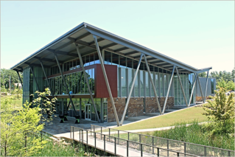

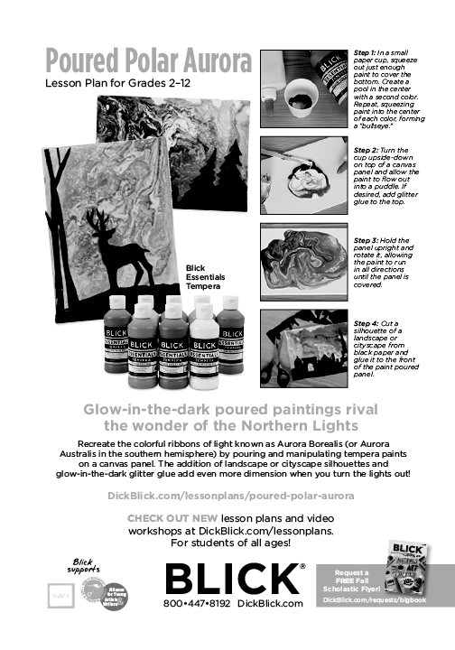

FRIDAY, NOVEMBER 2

(All sessions are one hour unless stated otherwise)

SC= Silver City (sections 1, 2, 3, 4, 5, 6), D-Decantillion, BD-Blue Dog,
Hospitality Suite - 1005
RW- Razorback West, RE-Razorback East
AT-Arkansas Traveler (upstairs)

HS- High School, MS-Middle School, E-Elementary, A-All Levels

7:30 AM Breakfast is provided to hotel guests in the restaurant.
Donut holes will be provided in the Hospitality Suite for those just arriving.

Session 053 8:00 AM - REGIONAL MEETINGS An open forum that will delve into the areas of art advocacy and will provide educators with information concerning student art work portfolios and exhibitions.

Northwest- Silver City 1 Northeast- Silver City 2
Central- Silver City 3 Western- Silver City 4
Southwest-Silver City 5 Southeast- Razorback East
Eastern- Razorback West

054 9:00 AM SC 1,2,3,4 Keynote Speaker Michael Warren
Excavating Originality
Inspiration is all around them. Endless accessibility is at their fingertips. Yet a timeless struggle persists: It is often difficult for our students to develop and convey truly meaningful and original ideas! Friday’s keynote session features Michael Warren, creator of Terra Forma Cards, as he addresses how we foster the divergent thinker in our classrooms.

Exhibits Silver City 7 10:00 AM – 12:00 PM
Educator Art Lab & Maker Space Silver City 6 10:00 AM – 12:00 PM
Teachers will experience hands-on learning by participating in various stations that will include ideas for STEAM and maker education. Come explore ideas for gaming, robotics, coding, animation and more as it ties to the visual art, design thinking, and studio habits. After participating enter for a chance to win some of the hands-on tools used.

003 Intervals North Parking Lot Van Gogh; A Mobile Art Center
Art Feeds presents Van Gogh, a Mobile Art Center dedicated to all things creative! We have paired with Sakura International to create a make and take project with their gel pens and cray pas, as well as a collaborative community art piece. Join us on board to relax, explore, express and get creative. This is on a first come first served basis.
10:00 AM, 11:00 AM, 2:30 PM, 3:45 PM
Limited A

FRIDAY NOVEMBER 2

055 10:00 AM SC 1 HSU Teen Summer Workshop David Warren
David Warren and Henderson Art Education students will present information about this amazing opportunity for teenage art students!
Unlimited A

056 10:00 AM SC2 Our Art and Our Community:
Building a New School Community One Project at a Time Sarah Benson
Join me in a journey with a new school, new students and the Arkansas Declaration of Learning Program. A partner with ADE and a program that helped to inspire and evaluate my students’ understanding of art, the connections to history and the value of art in communities.
Unlimited M, HS

057 10:00 AM SC3 Original Ideation: Terra Forma Cards Michael Warren
Fostering original and meaningful ideation in students can be difficult. This session is designed to offer tools for teachers to grow such abilities. Participants will work with Terra Forma Cards and see how they can be used in classrooms as a creativity catalyst.
Unlimited A

058 10:00 AM SC4 What Should I Do in the Background? Peggy Bollman
Even the experienced art students, after focusing on subject matter, are at a loss as to how to address the background. This session presents new ways of looking at how to help students’ problem solve this consistent obstacle with confidence. PowerPoint presentation and lesson plan available to all participants.
Unlimited A

059 10:00 AM SC5 Student Mentor Workshop Joy Schultz and Jocelyn Alvey
You will hear from high school and middle school students who participated in a mentorship workshop focused on finding an original voice, different techniques, and discussions about how artists create and stay motivated in a ChoiceArt studio.
Unlimited A

060 10:00 AM BD Let’s Share: Dips and Donuts
Nancy Abernathy, Gina Booth, and Patricia Singh
Phenomenal retired art teachers sharing tips, tricks, experiences and SNACKS with interns and new teachers. This is the place to be and learn what others don’t tell you! Possible mentorship connections and all your questions answered. These gals know their stuff!
Unlimited A

061T 10:00 AM D Gelli Printing Sue Anne McCoy and Angela Rosencrantz
Want to experience monoprinting with Gelli plates? Then this is the session for you! Participants will use acrylic paint, stencils and multiple other tools to create an original monoprint.
Ticketed A

Friday, November 2

062T 10:00 AM AT Beyond Words Sargent Art
An altered book page will be created using Sargent Art materials to create a unique found poem within the artwork. This artwork is about using recycled books. It is about words that create visual images and visual expression to illustrate the words. Reaching higher order thinking skills in this cross-disciplinary project is an added plus, all the while enhancing imagination and creativity.
Ticketed A 100 minutes

063T 10:00 AM RE Native American Effigy Pottery Jessica Cummings
This session will look at the styles, techniques and functions of Native Americans, specifically the Mississippian culture, Effigy Pottery. We will use these techniques to form face pots out of terra cotta and fool’s gold clay bodies. Techniques will include slab construction, coil building and modeling. All participants will leave with a face pot, which can be fired to Cone 6.
Ticketed E, MS, HS 100 minutes

064T 10:00 AM RW Create a Flawless Sub Tub Jeri Newberry
Teachers will come and assemble their own sub tub! They will leave with a complete set of lesson plans and other goodies in order to feel confident to leave for one day or many days.
This is geared toward elementary but can be adapted for any level.
Ticketed E 100 minutes

065 11:00 AM BD Media Exploration Lynn Smith
This presentation will review and/or demonstrate a variety of art media and techniques that students may choose to use in the production of their artwork. Many of the media processes can be used to alter the surface of the support for drawing and/or painting.
Unlimited M, HS

066T 11:00 AM Don’t Get Your Pantyhose in a Wad Stacey Glover
The concept of sculpture outside of clay can sometimes be difficult to think about in the art classroom with our budgets. In this session you will be shown how to create your own pantyhose wire sculpture. This project is adaptable from 4th grade to college. Note: This session begins at 11:00 AM and resumes after luncheon at 2:30 PM.
Ticketed A 100 minutes
Luncheon

12:00 – 2:00PM SC 1,2,3,4

067 12:00-2:00 SC 1,2,3,4
Paul Leopoulos of Thea Foundation and Meg Bourne of Art Feeds
Mr. Leopoulos will share information about grants and scholarships and Ms. Bourne will discuss the wonders of Art Feeds and the connection to community.

068 2:30 PM SC1 Grow Your Minds Jenny Cates and Bridget Fuhrman
I can learn, I can imagine, I can create! In this session you will find some ways to help your students get out of their fixed mind of “I can’t do it” and into their Growth Mindset of I can learn, I can imagine, and I can create.
Unlimited A

Friday, November 2

069 2:30 PM SC2 Helping Kids Find Love for Art Candace Snow
Ever have students who are just not interested in art? This session is about reaching out to those kids to inspire them to be motivated in art, and learn to love it as a creative outlet. We will be drawing, so bring a sketchbook and some things to create with.
Unlimited A

070 2:30 SC3 National Boards: How Do You Eat an Elephant? One Bite at a Time!
Troy DeBill
Learn why you CAN tackle the most challenging and rewarding professional development of your career. Learn all about the four components and requirements of NBPTS. I will share my personal journey and answer all of your questions!
Unlimited A

071 2:30 PM SC4 Lesson Share: Elementary and Middle School
Sharon McDuffey and Annie Morgan
This presentation is designed as a share session. Bring several copies of your favorite lesson plan for elementary or middle school and prepare to share.
Unlimited A

072 2:30 PM SC5 Hungry? Don’t Eat It, Its Toilet Paper! Jenna White
Looking for a way to gain 100% engagement? One thing all kids love is food! In this session, you will learn how to engage your students by using a non-traditional medium- TOILET PAPER- to create realistic looking food sculptures. This lesson can be adapted to any grade level. It is cheap, super engaging, and definitely an attention grabber!
Ticketed A 100 minutes

073T 2:30 PM BD Sewing Silly Creatures Allison Cole
Join us in this session to experience this super sweet, 2D & 3D, literacy rich, fiber arts project that captures design at its silliest. We will discuss all aspects of this project and create our own character with a story. Student example and ideas will be shared.
Ticketed A 100 minutes

074T 2:30 PM AT Narrative Necklace Sue Anne McCoy
This is the perfect project for the start of the school year or a new semester! Gets your students creating art immediately and allows you to get to know them as individuals. Let them tell you their story in a creative, inexpensive necklace!
Ticketed MS, HS 100 minutes

075T 2:30 PM RE Artist to Superhero Sharon Boyd-Struthers
Think… Wonder Woman, Marvel, Black Panther, League of Justice and others. Select and research an artist, determine how they perceived and influenced the world. Artist becomes the superhero, who identifies the problem, resolves or overcomes the problem and determines how the issue ends.
Ticketed E, MS 100 Minutes

Friday November 2

076T 2:30 PM RW Advanced Drawing Warren Utsler
This presentation will guide participants in creative explanation of a self-portrait. Please bring a digital device for taking your image. Participants will also need a Sketchbook, pencils and a vivid imagination to explore your own thoughts, favorite places to go in your mind, or those recurring daydreams. A lesson handout will be provided along with a sequential slideshow presentation that can be downloaded.
Ticketed HS

077 3:45 PM SC1 Line Dynamics Cheryl McMickle
This presentation will show how to propose problems to students for exploring design with line variations. From developing thumbnails, to exploring concepts like increase, velocity, continuity, and space, to finally creating finished works - this unit does it all with LINE. Lesson plans, resources, templates and examples will be shared.
Unlimited HS

078 3:45 PM SC2 It’s All About ME! Dewana McIntosh
This presentation is an interactive session where you will take away a great get to know me activity. Use it for the first weeks of school or an introductory portrait lesson. You will have access to the slides and several approaches for use in the classroom. Adaptable for all age groups!
Unlimited A

079 3:45 PM SC3 My First Year of Choice Based Art Rachelle Tracy
This presentation is a look at my first year facilitating a Choice Based classroom with middle school students. Find out why I chose Choice Based art, and discussions on implementing stations, my successes and failures. Discover how I used recorded videos of demonstrations to teach 30 students, 10 different mediums, simultaneously.
Unlimited M, HS

080 3:45 PM SC4 Just Google it Tiffany Cassidy
This session will provide educators with a brief overview of how Google Apps Docs, Classroom, Drive, Sheets, and Slides work. We will also cover how I use these apps in my art classroom. While I primarily teach elementary, I will discuss tips and tricks that will work in K-12 classrooms. Even if you are not connected 1-1 with technology the Google apps can make your teacher life easier!
Unlimited A

081T 3:45 PM D Come STEAM it Up! Jenny Cates
In this presentation participants will learn how the arts and math can interlock in this steam workshop. They will use art to create a geometric work.
Ticketed E

082 3:45 PM RW Literacy in the Art Classroom- It’s Not Just Reading A Book
Jennifer Henley
In this presentation I will discuss ways in which literacy can be incorporated into the art classroom. A variety of methods will be shared including art analysis, poetry, and collaboration with classroom teachers, research, non-fiction reading, artist biographies, and incorporating technology.

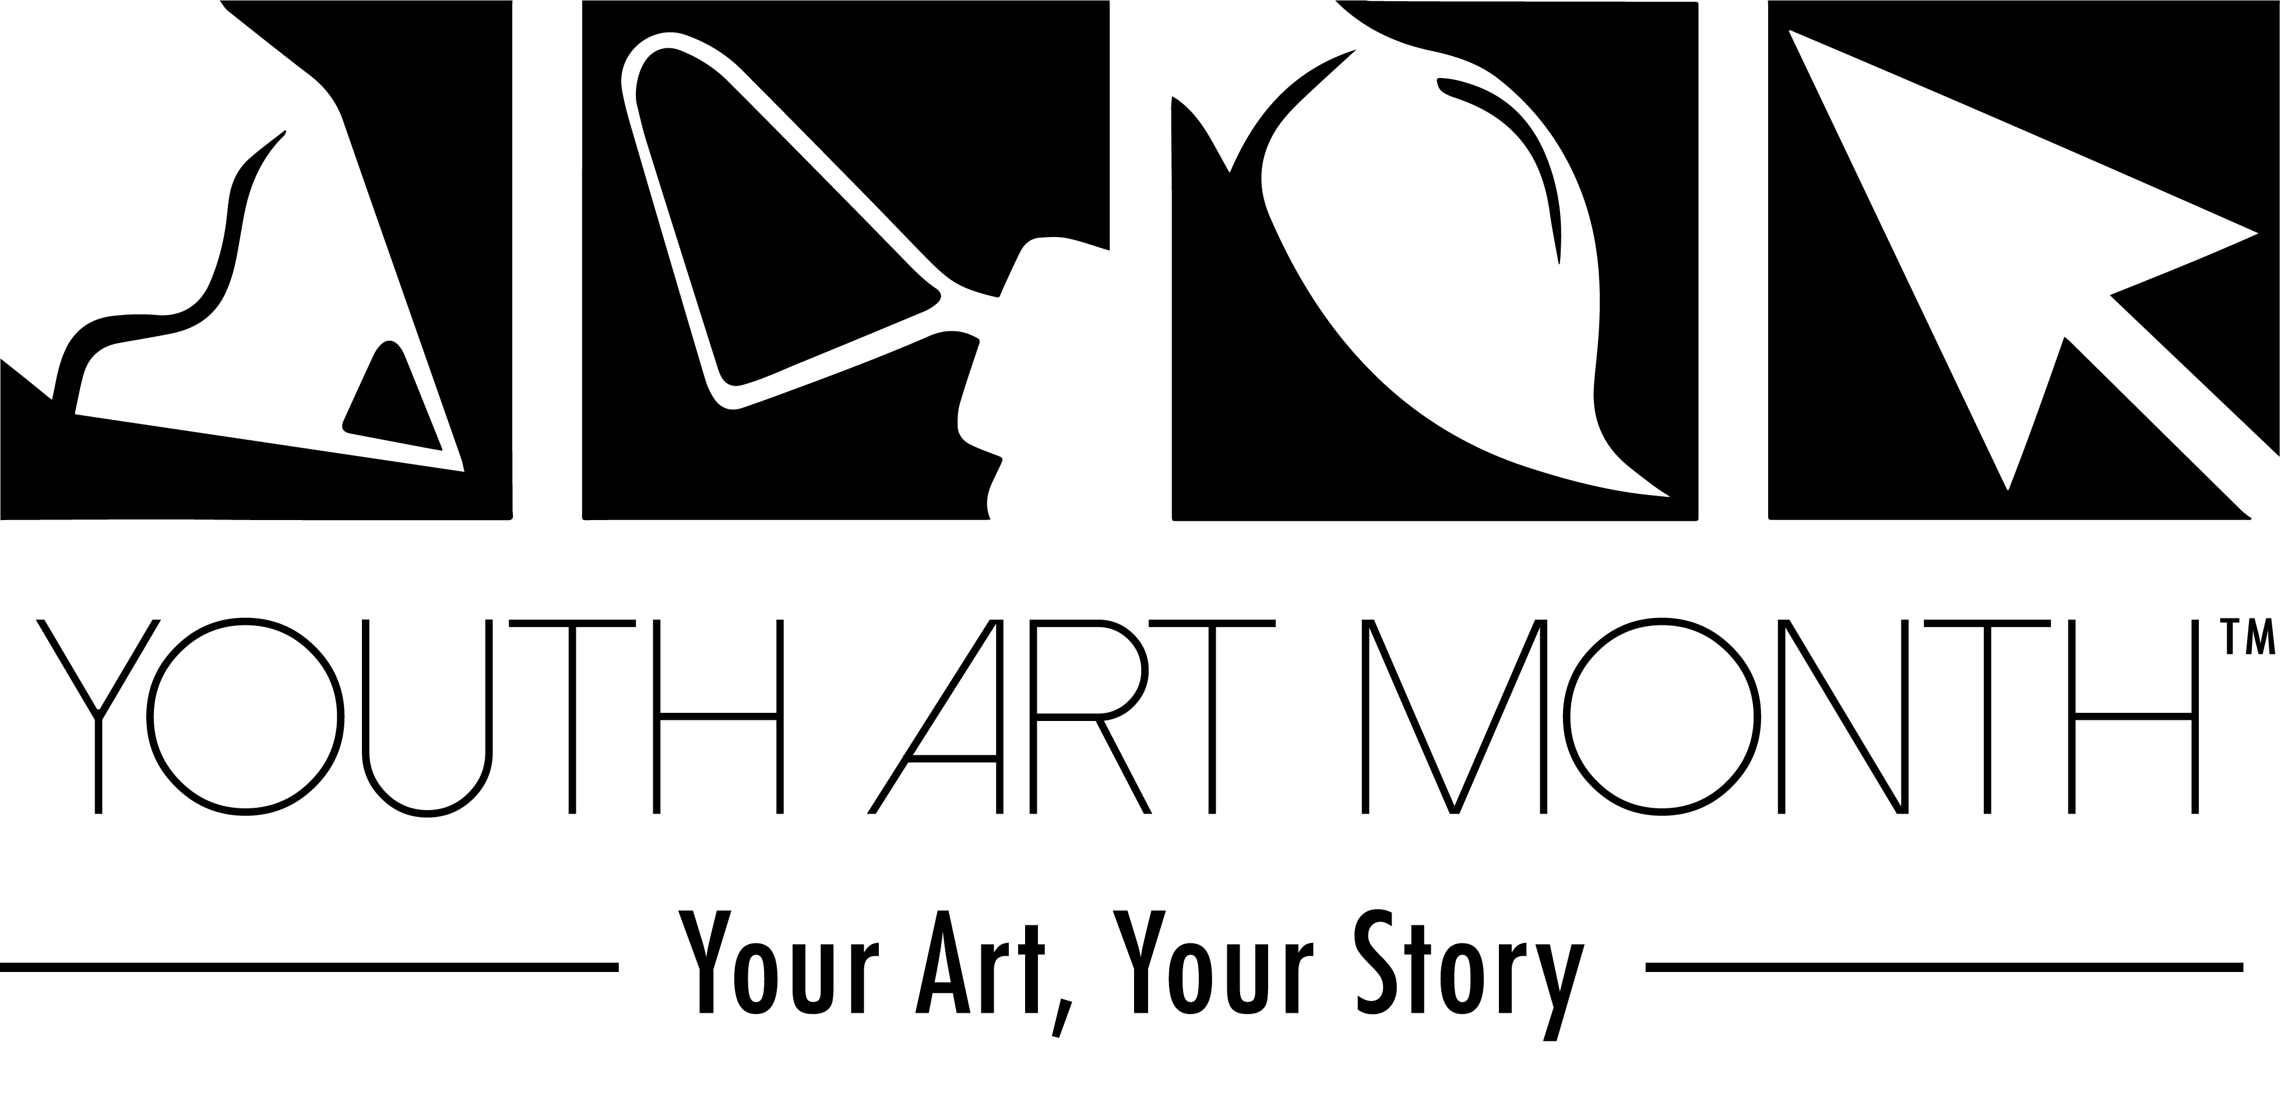
We have a great theme to work with this year!
All flag/banner designs must be emailed by December 8, 2018, so start planning now!
Please don’t forget to document all March activites, take pictures and send to me for our scrapebook! For complete details & entry forms go to our website ararted.org and go to youth art month page.

Contact YAM Chairperson: Amber Lemser al151823@gmail.com for more information or questions.

Congratulations to Amber Lemser for getting special recognition for the YAM Scrapebook for Arkansas 2 years in a row!
We are so proud of you!

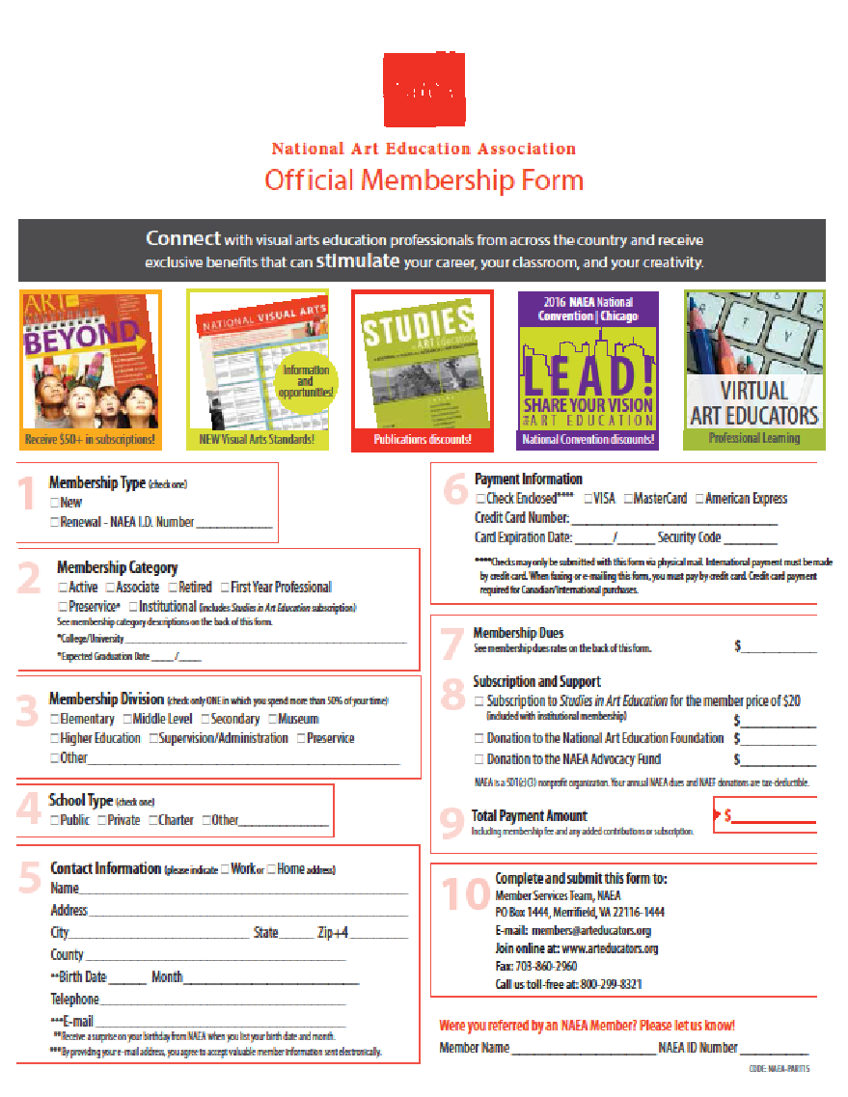

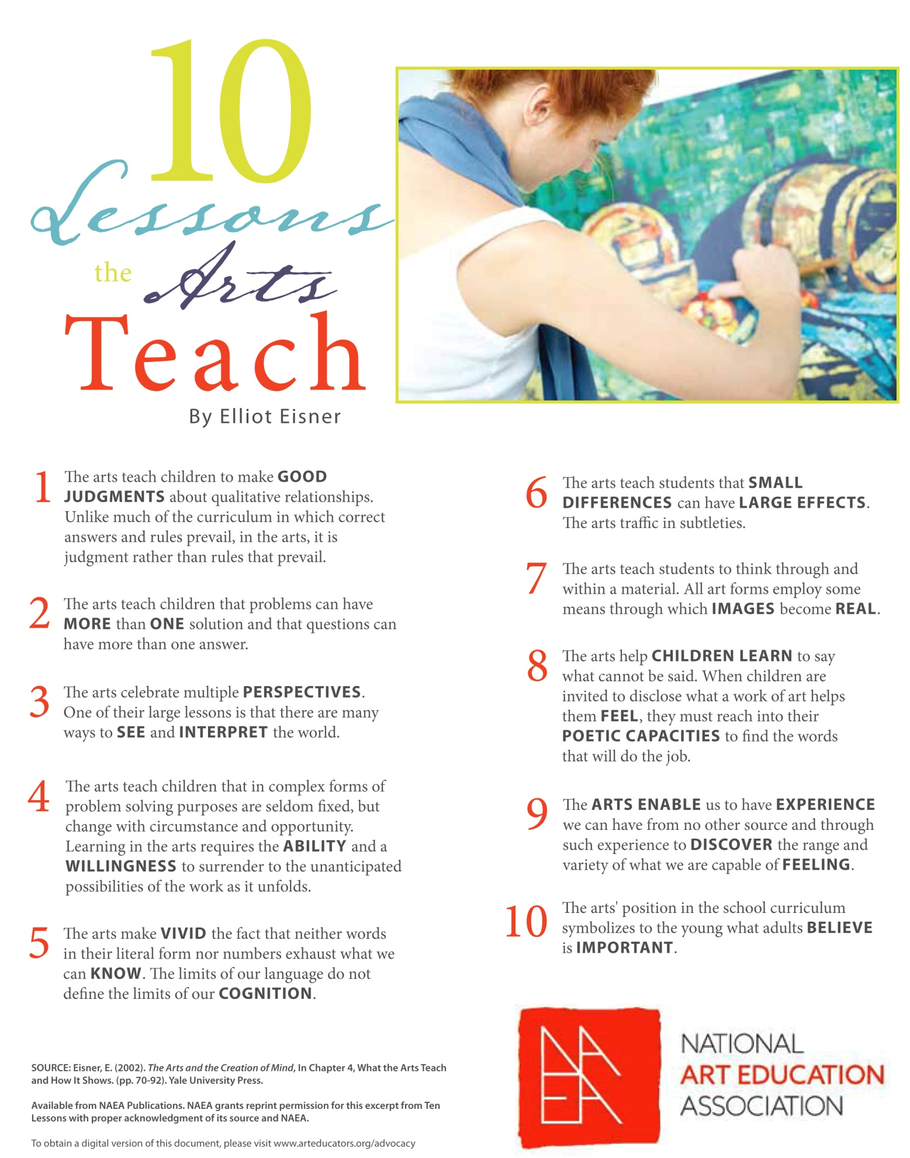

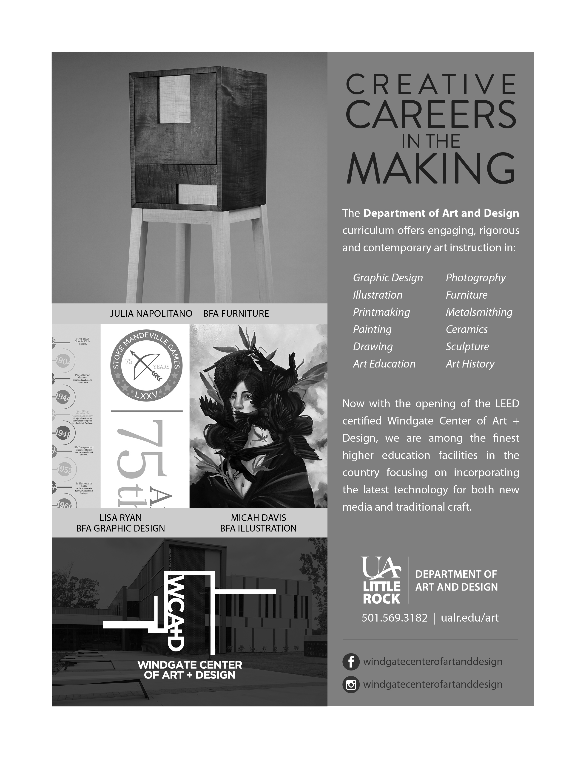

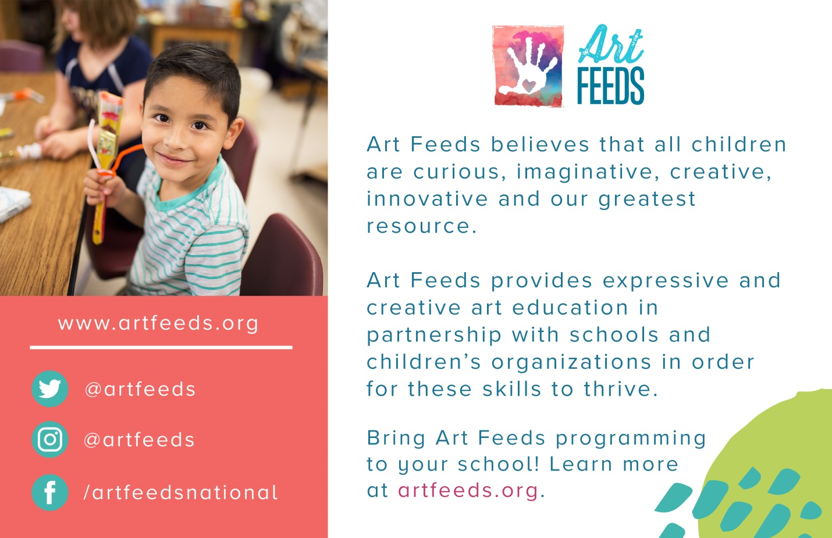

Conference Notes

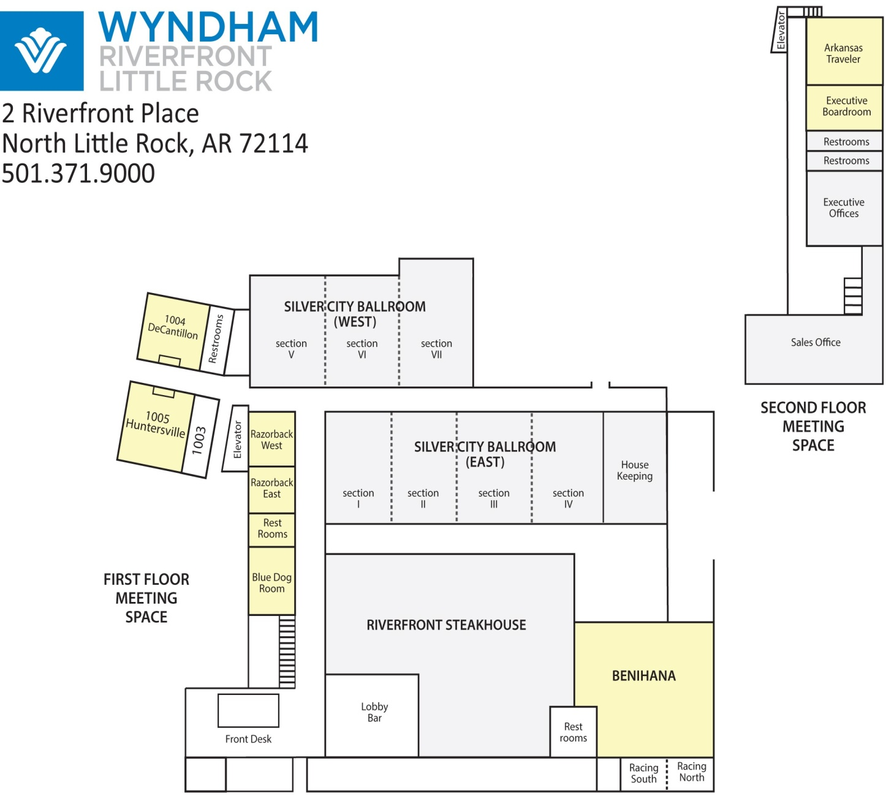
Art Feeds Van Gogh

