Demystifying the Process of Creativity Name__________________________________________
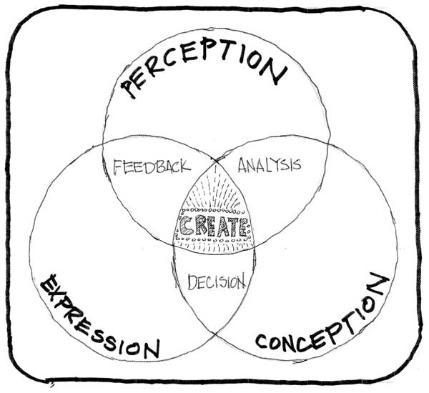
Creative Process (for REAL)
- This is going to be Awesome
- This is hard (modify)
- This is terrible (change)
- I’m terrible (change even more)
- Hey not bad (growth!!!)
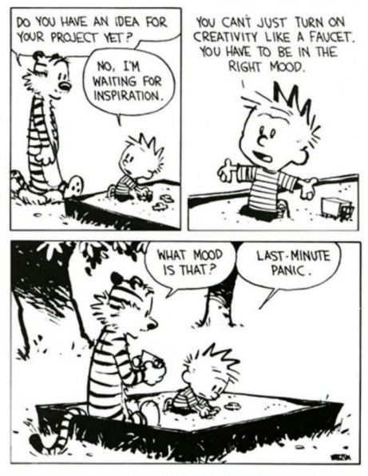
- This is Awesome (discovery!)

In the space below you are to illustrate your creative process through sequential illustration.

