SHOETACULAR Art Lesson Plan
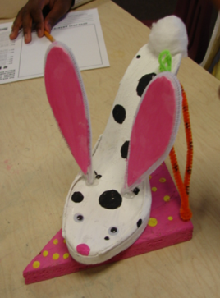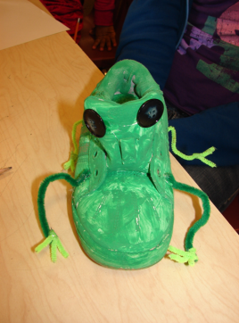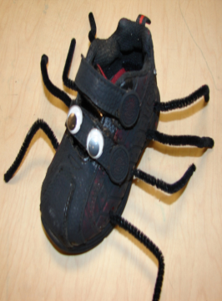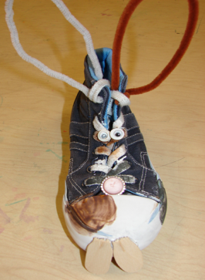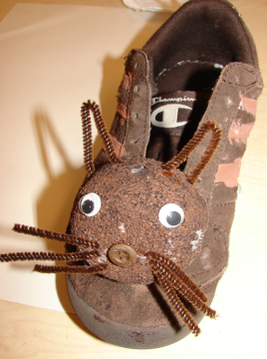
This Lesson is adapted from the article “Fantastic Footwear-Recycle, Retread, and Reboot!” In the October 2005 issue of SchoolArts magazine by Esther Wohl.
Concept: 3-D Art
Grade: Sixth
Lesson: Fantastic Footwear
Frameworks: CR.1.6.1, CR.2.6.1, CR.2.6.2, P.6.6.2
Objective:
- Students will crete a 3D mixed media sculpture using a shoe.
- Students will plan and develop this “Fantastic Footwear” project utilizing imagination with creative sketch ideas.
- Students will produce and execute their designs using recycled objects to build their sculpture.
Vocabulary: Sculpture, Recycle, Reuse, Mixed Media
Materials:
- Shoes
- Paper & Pencils (for sketching)
- Assorted recycled objects (see detailed list below)
- Assorted arts and crafts materials (see detailed list below)
- Scissors, X-Acto Knives
- Glue
- Glue Gun and Glue Sticks
- Paint, paint trays and brushes
Process:
1. Once a shoe is selected the Student is to place it in front of them and look at it from all directions. They should think and consider the possibilities of what this shoe could be transform into.
*Examples of other shoe project can be shown to give students ideas or rely totally on the student’s imagination and creative thinking skills.
2. Students are to plan and develop ideas utilizing their imagination and sketch 3 different illustrations for their project.
* Tell students that the Shoes can be cut into, pieces, cut off, items can be added to create their desired design. Animals, insects, birds, automobiles or other transportation, and people are some of the possibilities.
* A conference with students could be done after step 2 to discuss possible designs choices if desired.
3. Students are to execute their designs using various supplies and recyclable materials available to build and create their shoe sculpture.
4. When finished display artwork!
How to get prepared for this project:
- Collect Shoes
  - Ask for donations.
  - Have each student bring in an old shoe that is no longer used.

- Gather various supplies and materials to aide in the students’ creations.
  - Recycled objects:
Wood scrap pieces, shoe boxes, wooden spools, dowels, pop cycle sticks, cardboard, cotton balls, buttons, film canisters, pringles cans, fabric, Styrofoam, egg cartons, toilet paper rolls, paper towel tubes, scrap paper, craft foam, felt, yarn, etc.
  - Arts and crafts materials:
Pipe cleaners, beads, jewels, pompoms, buttons, feathers, tissue paper, google eyes, sequins, glitter, yarn, etc.

- Have the various materials and supplies out and readily available during class time for students to create and work with.
*Suggestion – teacher should have a station set up for the hot glue gun and be in charge to prevent burns! I had students come to me and I glued the extra objects to the shoes where the students wanted the items placed.
Links for Artists who use Recycled Material/Shoes in Art
Lisa Kokin
http://www.lisakokin.com/sculpture-one.html
Michelle Reader
http://www.michelle-reader.co.uk/
Jane Perkins
http://www.ignant.com/2014/02/03/recycled-art-by-jane-perkins/
Old Shoes Reborn as Living Faces
http://recyclenation.com/2010/11/shoes-reborn-recycling-living-faces
11 Artists Doing Amazing Things With Recycled Materials | Mental Floss
http://mentalfloss.com/article/13046/11-artists-doing-amazing-things-recycled-materials
Recycled Art: 66 Masterpieces Made From Junk - Hongkiat
www.hongkiat.com/blog/recycled-art-masterpiece-made-from-junks/
The most famous shoes in the Art History
https://www.youtube.com/watch?v=cOjyf5QU4v
Design a shoe to be marketed.
http://www.bucketfeet.com/

