Monochromatic Index card portraits
A CHEAP, easy way to teach all the elements and principles, include EVERY student in a display, and have a real “WOW” factor on the wall. I found this project online from Cassie Stephen’s blog. Check her out if you have time-she’s really awesome! How I did it:
- Buy enough blank index cards for every kid to have one, then also buy an extra package for the “I messed ups” and the “Here’s a new student for my class” kids.
- Collect colored pencils and coordinating markers together so that each table has a particular color such as red. Red colored pencils in a cup (with a small hand sharpener) and a basket with red markers in it, both on a table.
- If you have mirrors put them out for students to use as well, but if not don’t sweat it. They will be fine without them.
- You will also need extra-fine Sharpie markers for students to use to trace over their pencil lines with. Make sure they understand it is a permanent marker and what all that means to them!
- Prior knowledge needed for this project is;
(a) an understanding of what a pattern is, (b) how value works using a colored pencil (pressing harder for a darker value, lighter pressure for a lighter value), (c) sharpening colored pencils,(d) how to trace over lines with a marker, (e) what a self portrait is, and (f) what a background and foreground are.
- If you teach Pre-K and Kindergarten you may want to prep cards for these students by drawing a head and shoulder outline with Sharpie marker on their cards ahead of time. However, I found that this causes confusion for some students as they don’t understand they are to fill in their features and you must demo this for them.
- Show Cassie Stephen’s video on Monochromatic Self-Portraits found at: https://youtu.be/yYCl0dtG2Kk. It takes about fifteen minutes to watch it, and is well worth the time. However, you may opt out of it (as I did in certain circumstances) because you may already have a procedure in place that you use when drawing “selfies”.
- You may find it a great opportunity to introduce your favorite artist/artists who have done self portraits. Chuck Close, Van Gogh, Kahlo, Rembrandt etc. Class discussion on the subject can be very engaging and a great time for a little “this is what I see” critiquing.
- Allow several weeks to complete these portraits if like me you only see your students once a week for 45 minutes! Week 1 is video and demo week, week two is draw and ink week, week three is color week. There will always be stragglers, absences, tardy to classers so just let them complete these as they can and add them along the way to your display. It actually works well because of using dry media to allow students to finish these “along the way” if they get behind. When one gets finished it’s fairly simple to add their card to the display.
- Display is the best part of this project so prepare to have a large enough wall space to get everybody up at once. Plan your display out-will you want to put colors together in a “rainbow” , or maybe a hodgepodge of all the colors in random order, by grade level, by class etc. I have cinder block walls so hanging can be difficult. I have found that using double sided tape and scotch tape works best for me. I put a small piece of double sided tape on the back of each card and scotch tape from the under side around both sides and the bottom on the very first card. This way the card sticks to the wall and has three sides with tape facing out to stick the cards around it to. This way of taping leaves you ready to stick the next portrait up alongside the last one placed and putting tape on two sides each time instead of more. Mine have been hanging for over a month now and so far none have fallen or became dislodged even though they are in a high traffic area and within hands reach of students. Allowing students to help you is also a great learning experience. Some may be able to apply tape to their portrait and place it themselves, others may only be able to place it, and still others may only be able to put a piece of double sided tape on the back of their card. But at whatever level a student may be, just seeing their face up on the wall will give them a good learning experience.
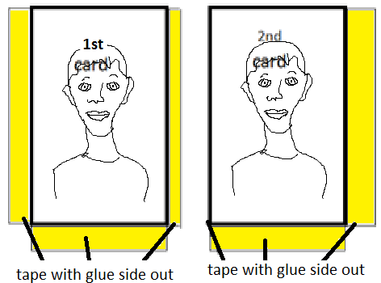
Once completed the display can be carefully taken apart by older students once they understand how to loosen the edges of the tape and gently peel the cards apart, removing the double sided tape last. Of course you may need to do this yourself if like me you teach younger students who could not be expected to do such a task without tearing up most of the work. Be sure to take lots of pictures and send to me! shelmand@hssd.net. I truly hope you enjoy this project and find it helpful for your student’s learning and engagement inside the art classroom. If I can be of any help to you please feel free to contact me at the above email address or Facebook me!
Thank you!!

