Oil Pastel Color Theory
Presented by Lisa Kraus
E-mail: lkraus@horatioschools.org Website: http://www.heslionsart.weebly.com

Who is this lesson for?
This lesson has been tested in 5th, 6th, 7th, and High School art classes. I also teach a simpler version of this lesson in 2nd grade. With adaptation, this lesson can be used at all levels.

Essential Question Ideas:
How do artists use color? OR How do artists view the world?

Ideas for Focus Artworks:
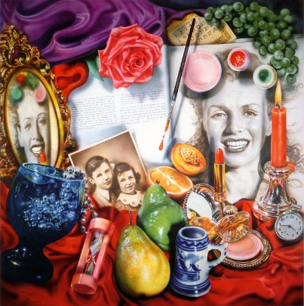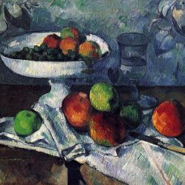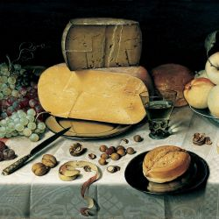
Audrey Flack, Marilyn (Vanitas), 1977
Audrey Flack, Marilyn (Vanitas), 1977 Paul Cezanne, Fruit Bowl, Glass, and Apples, 1882 Floris Claesz van Dijck, Still Life with cheese, 1615
ELA Connection:
Give each student a paint chip, have them write words that describe the paint color. Example on an orange paint chip a student could write: pumpkin, sunset, basketball, tiger lily, etc.
Science Connection:
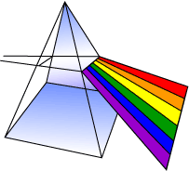
Light is made up of every color of the rainbow. We see this when light passes through water or a prism and is broken down into all of its parts.
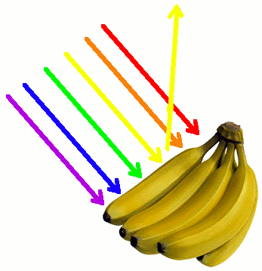
When light hits an object every color is absorbed EXCEPT the color we see. That color bounces off of the object and back to our eyes.
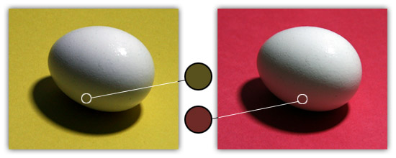
The color of an object also reflects onto the color of the objects that it is next too. This is called reflected color and is very easy to create with oil pastels.

Still Life Steps:
- Draw the shapes of the object. (You can also discuss composition, drawing large, and the use of view finders).
- Choose 3 colors for each object. A medium tone for the mid-tone (I explain this would be the “coloring book color”), a darker shade for the shadows, a lighter color for the highlights. Do not include white or black yet.
- Begin by coloring the entire shape with your mid-tone, add the shadows and high-lights then gently blend them together following the shape and curves of the object.
- Repeat step 3 with every object on the page, including the background.
- Black & White are like salt and pepper. You only need a tiny dash to season it, too much will ruin it. Use a tiny bit of black and blend to create the darkest shadows. Use white following the curve of the object to create the highlights – do not blend the white.
Working impasto:
Instead of using your finger or a blending tool to blend the pastel use heavy layers of pastel and use the pastels themselves to blend the colors together. You will need paper towels on hand to clean off pastels as you use them.
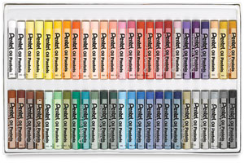
Oil Pastels:
Any brand of oil pastels will work for this project. You may use any pastels you have on hand, or any brand that you prefer.
If you don’t know where to start, I prefer Pentel Oil Pastels sold in a set of 50. (Blick sells these sets for $6.10 each, I typically buy 6 sets a year for $36.60 and my students share the sets)
Cleaning Pastels:
If your oil pastels get dirty you can use cornmeal to clean your oil pastels. Put the cornmeal in a container, add the pastels and mix them together. You can use the cornmeal multiple times.
Want to see it on a video?
http://www.jerrysartarama.com/art-lessons/Medium/Pastels/Pastels-Cleaning-Your-Pastels.html

