Paper Sculpture
Presented by Lisa Kraus
E-mail: lkraus@horatioschools.org Website: http://www.heslionsart.weebly.com
Project 1:
Design a modern playground.

Ideas for Focus Artworks:
Claes Oldenburg, Spoonbridge and Cherry,29 ft., 1988 Artist Collective mmmm…, BUS, 14 ft., 2014 Patrick Doughtrey, Stick Sculpture, 2014
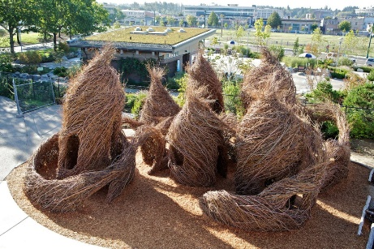
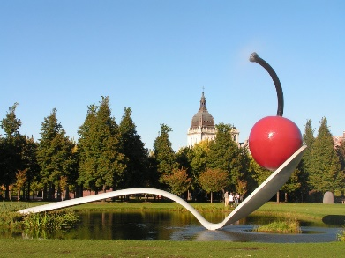
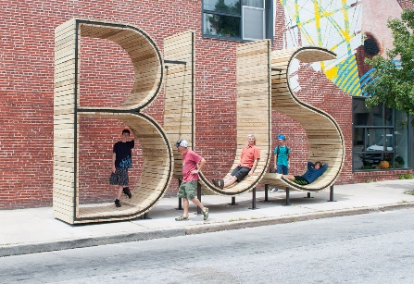

Project 2:
Create a three-dimensional story.
Steps:
- Create a sketch of your design.
- Divide your sketch into three pieces: A foreground, middle ground and background.
- Draw tabs onto three pieces of paper.
- Trace each step onto a different sheet of paper, checking them for alignment.
- Use the media of your choice to color each page.
- Cut out the empty areas of each sheet of paper.
- Create 2 accordion folds to use for the sides of your artwork.
- Glue each scene to one of the folds.
- Let it dry.
Project 3:
Create a sculptural drawing.
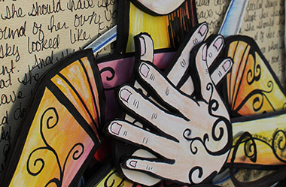
Steps:
- Create a sketch of your drawing.
- Decide how your drawing will be layered.
- Draw each layered piece as an individual part that fits with each other part.
- Color each piece with the media of your choice.
- Cut out each individual piece.
- Glue pieces to foam board to create layers.
- Assemble your artwork.
Bonus Project:
Use a paper towel roll as a form, and cover it with making tape and newspaper to create a sculpture. After you have completed your sculpture you may paint it or draw on it.

Basic Techniques:
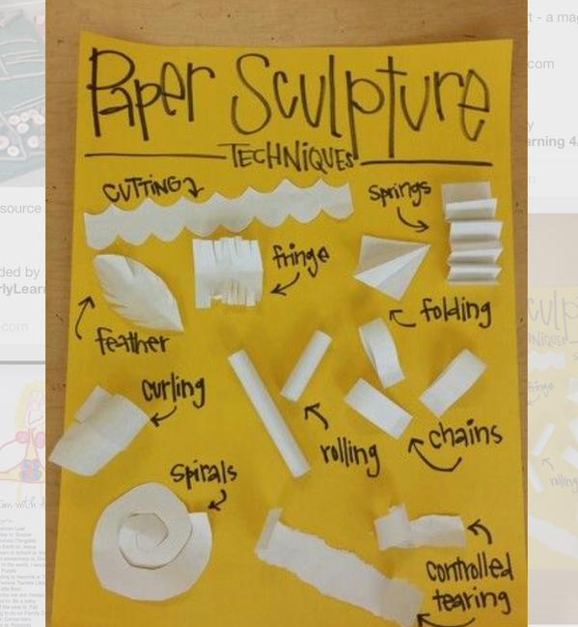
(This image was on Pinterest. Everything I could find sourced back to this link, if you find a different source please let me know.) https://twitter.com/wonderstaples/status/559678558516563968

