LESSON: Visual Journal
LEVEL: Middle-High School | Time Frame 2.5 hours
OBJECTIVES | METHODS/ACTIVITIES
Wk.1 • Identify facets of their personal identities.  • Observe and analyze how race, religion, family and other factors  influence the identity of a school student seen in a series of video  clips.  • Create self-portraits made up of objects, symbols and/or imagery that  represent key elements of their identity.  • Explain what objects they included in their self-portraits and how they  relate to their personal identities.  Wk. 2 Students will construct a traditional book blinding constructed visual journal using recyclable collage covers for front and back covers. | Wk1. Discuss what is a self-portrait. We will look at famous artist self-portraits. Using the VTI instruction students will view Romear’s (Neighborhood) and Hoch’s (Kitchen Knife). We will discuss how to make a portrait using pieced images. Teacher demonstration in cut and glue techniques.  WK2. Students will fold 9X12 white construction paper in half in sets of five folded papers. Students will tape the center fold of each placing each fold side together and tape, then fold over place next folded page then tape to create a set of five folded pages. Students will make five sets of five. Placing folded sides together tape sections together.  Place collage cover face vertically side by side with ½ inch gap between, place 9” strip of duct tape down the center. Turn the covers over place page sets in the centerfold over the covers to enclose the sets connecting the duct tape to folds of pages. Open the cover place masking tape over the fold edge and cover edge to attach covers to duct cover page. Repeat for back dust cover.
STANDARDS (SLEs)
Visual Art;
Master Artist: Romear Bearden, Hannah Hoch,
Dadaism, Harlem Renasauance
CR.1.4.1 Individually formulate multiple solutions to an art or design problem through brainstorming (e.g., collage combining previous work, paperclip sculpture, found object printing)
CN.10.4.1 Create artwork about community life events (e.g., festivals, traditions)
MATERIALS
5X7 chip board
Magazines
Glue
Construction paper
Sharpies
Masking tape
Duct tape
White recycled paper

INSTRUCTIONAL STRATEGIES
Explore areas of interest in depth; conceive of, plan, and execute a research or creative project from beginning to end; work independently; seek mentorship from an expert in the field.

VOCABULARY | INTERDISCIPLINARY CONNECTIONS
Book Binding Terms; spine, set, spread, dust cover, end page  Representation  Objective verses non-objective  Symbolism  Identity  Dadaism  Harlem Renasauance | Family Consumer Sciences, Language Arts,  Family/Consumer Sciences, Standard 1: Understand the family as the basic unit  of society.  Family/Consumer Sciences, Standard 2: Understands the impact of the family on  the well-being of individuals and society.  Family/Consumer Sciences, Standard 10: Understands how knowledge and skills  related to child development affect the well-being of individuals, families and  society.  Language Arts, Standard 9: Uses viewing skills and strategies to understand and  Interpret visual media.
RESOURCES | ASSESSMENT
http://www.beardenfoundation.org/artlife/biography/biography.shtml  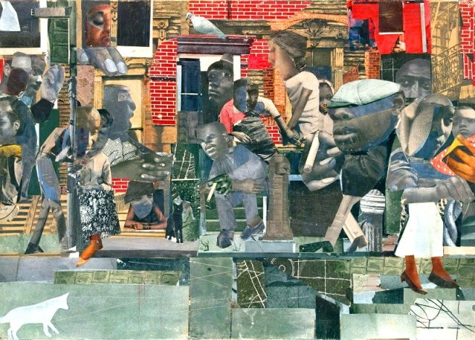  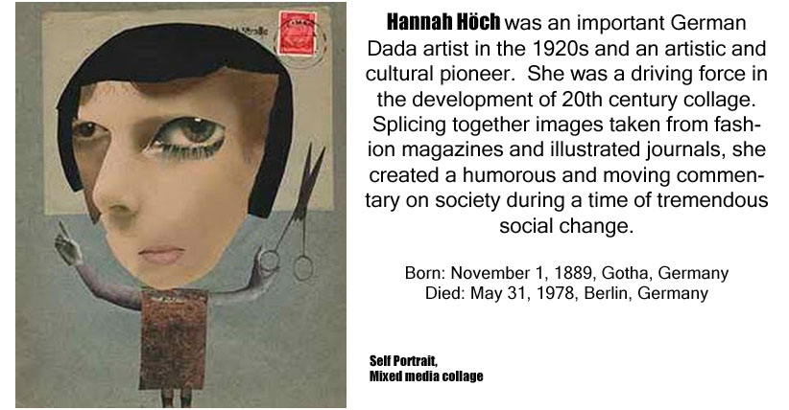  http://www.theartstory.org/artist-hoch-hannah.htm  Follow up Power Point: | Product  Check list  Creative Process journal and reflection

